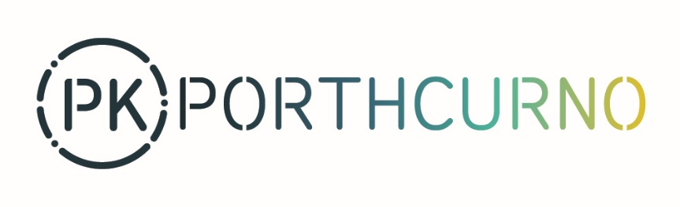

Learning Facilitator (Arts)
Reports to: Engagement Curator
Contract: Casual worker
Hours: Regular hours and during school holidays (essential)
Pay: £15.86 per hour
Holidays: Annual leave entitlement for every hour worked
Based at: PK Porthcurno, Eastern House, Porthcurno, Cornwall TR19 6JX

Overview
The museum is looking for a Learning Facilitator (Arts) to facilitate our holiday things to do and community group visits, be the main point of contact for our Cable Stitchers volunteers’ group and develop museum resources and playful interventions.
The successful candidate will be experienced in delivering accessible, family friendly workshops and informal community group visits in a museum or arts setting. We seek a creative, highly organised, and flexible worker to support our Engagement programme.

Job scope

Responsibilities
- Plan, prep and facilitate PK holiday ‘things to do’ and community group visits, developing ideas that are accessible to a wide range of ages and abilities.
- Risk assess for these activities and visits either onsite, outreach and/or remotely.
- Collection of photography and other permissions for audience GDPR purposes.
- Support design and development of museum resources and playful interventions.
- Main point of contact for Cable Stitchers volunteers and coordination of their meetings.
- Sharing weekly team minutes and any other relevant information from the PK team with Cable Stitchers volunteers.
- Collecting audience participation numbers and feedback at workshops, group visits, and events.
- Attend regular team meetings, support Engagement Curator with reporting and other tasks as and when they arise.
- Adhere strictly to COVID- 19 Government Guidelines and advice to ensure safety for all.

Person specification
Essential
- Excellent arts/crafts/making skills.
- Excellent organisational skills with the ability to work unsupervised and to manage own time to meet briefs, targets, and deadlines.
- Experience of delivering community group visits and family activities.
- Experience of supporting group visits and events.
- Welcoming persona to museum visitors.
- Strong IT skills.
- Excellent communication skills with clear reporting on progress.
- Keeping up to date with Government Guidelines and advice on COVID-19.

Desirable
- Experience of working with volunteers of all ages.
- Be creative, playful, and open to new ways of working.
- Experience of working with early years, children, young people.
- Experience of working with older years.
- Strong design skills.
- Strong research skills.
- Safeguarding training.
- First Aid training.

Application process
To apply please email a covering letter that addresses the criteria as set out in the job scope and person specification, CV, and completed Equal Opportunities and Personal Details Forms to: info@pkporthcurno.com

Please quote job ref: LFA2021 in the email subject header
Closing date for applications: Monday, 19th April 2021, midnight
Interviews: Tuesday, 27 April 2021 in Porthcurno (preferred) or via Zoom

The Porthcurno Collections Trust (The PK Trust) is a registered charity no.1062233. The Trustee of The PK Trust is Porthcurno Limited, company no.3323350, registered at Eastern House, Porthcurno, Penzance, Cornwall TR19 6JX

